Prediction to Prescription – Medical Appointment No-Show Prediction and Overbooking Policy Prescription

Owen Bao, David Izrailov
15.095 Machine Learning Under A Modern Optimization Lens
December 15, 2025

Problem
We aim to solve the issue regarding no-shows for medical appointments. For each person who misses their appointment, a doctor must idle until her next appointment. In addition, the patient who did not arrive precludes another patient from being treated during that time slot. For this reason, we predicted no-shows, which alone can be very helpful in designing clinical schedules. In addition, we add a prescriptive component where we offer an overbooking policy to solve the two issues associated with no-shows.
We are aware of the risks that come with overbooking, which is why an optimization approach is used to ensure the best results. A solution to this problem will lead to more efficient clinics, and more patients treated, overall increasing the quality of care.

Data
The Data we used came from Kaggle and can be found here. The dataset contains information about 110,527 appointments in Vitória, Brazil. Vitória is the capital city of Espírito Santo state in southeast Brazil and is home to around 300,000 residents.

The given features can be seen below.
Feature | Description
Patient ID | Identification of a patient
Appointment ID | Identification of each appointment
Gender | Male or Female
Schedule Day | The day of the actual appointment
Appointment Day | The day someone booked the appointment
Age | Age of patient
Neighbourhood | Where the appointment takes place
Scholarship | If Patient has Financial Aid: 1, Not : 0
Hypertension | If Patient has Hypertension: 1, Not : 0
Diabetes | If Patient is Diabetic: 1, Not : 0
Alcoholism | If Patient is Alcoholic: 1, Not : 0
Handicap | If Patient is Handicapped: 1, Not : 0
SMS_received | If Patient received SMS: 1, Not : 0
No-Show | If Patient is a No-Show: 1, Not : 0

Some important summary statistics can also be found below
Feature | Description
Age | Contains ranges of
No-shows | 80/20
 | Owen fill this in

To aid in our prediction, we added a column for lead time (date scheduled – appointment date) as we think this is relevant to no-show probability. In addition, we standardized our two numeric features: age and lead time.

Approach - Prediction
The very first thing we did was run a baseline logistic regression model: OWEN RESULTS HERE

Using IAI in Julia, we predict using RandomForest, CART, and OCT. We conducted a rather small grid search given limited compute and long runtimes. The table below summarizes the grid search results
Parameter | Model
Parameter | RandomForest | CART | OCT
Max Depth | 15 | 12 | 6
Num Trees | 200
Minbucket | 100 | 200 | 200

We chose this set of models because they range in terms of predictive power and interpretability, while still being similar and a fundamental model level. Given more time, we would have tried other classifiers including SVM, XGBoost, and OWEN ADD HERE.
Each model was trained with 3-fold cross validation, and a validation criterion of AUC. We also measured accuracy via misclassification.
The overall runtime for the prediction component is just over an hour, with OCT alone taking about 40 minutes.
Results - Prediction
The overall results are as follows
Score  (Out of Sample) | Model
Score  (Out of Sample) | RandomForest | CART | OCT
AUC | 0.7331 | 0.724 | 0.7253
Accuracy | 0.7978 | 0.7981 | 0.7981

As expected, RandomForest has the highest AUC (the metric we trained models to maximize). Though, the single tree models were very close behind, and come with interpretable rules to understand no-show prediction. Below is the CART:
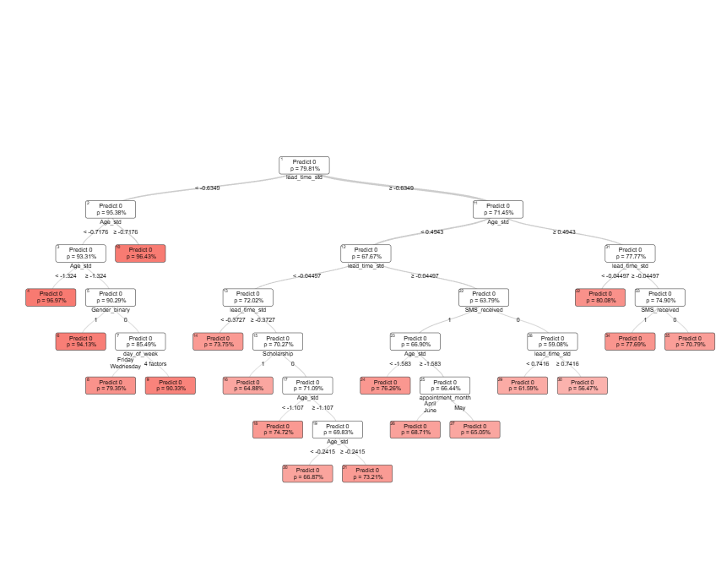
And the OCT:
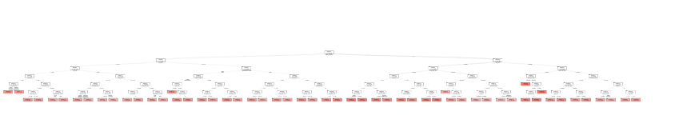
Despite OCT having a smaller depth, it surprisingly looks far less interpretable.

Approach - Prescription
To facilitate the overbooking policy, we chose to use the prescriptive method framework.
$${\hat{z}}_{N}(x)=arg⁡\underset{z∈\{0,1\}}{min⁡}\sum_{i}{w_{i}}(x) c(z;y_{i})$$where $w_{i}\left(x\right)$ is the weights from a model, $c(z;y_{i})$ is the cost function, and $z$ is either 1 or 0, where 1 is overbook a given slot and 0 to not.
We chose to try all three models (CART, OCT, RandomForest) as our weights. As for our cost function, we had to make some assumptions. We needed two costs:
- Cost of idle physician – Cost associated with a missed appointment
- Cost of patient delay – Cost associated with overbooking when it was not necessary
We believe that the first cost should be higher than the second as less patients are seen under that case. As such, we decided to make cost 1 the hourly wage of a physician in Brazil, around 150 BRL, and cost 2 half that at 75 BRL (note 1 USD $≈$ 5.42 BRL). While we understand that these numbers are not the most concrete, we believe that the ratio is about right. We experimented with several ratios for the cost grid and this configuration lead to the most reasonable policy.
As such, we end with the following cost grid.
Decision | $y_{i}=1$ (No show) | $y_{i}=0$ (Show)
$$z=0$$ | 150 | 0
$$z=1$$ | 0 | 75
This leads to the following cost function:
$$c\left(z;y_{i}\right)=1\left\{y_{i}=1\right\}\left(1-z\right)\left(150\right)+1\left\{y_{i}=0\right\}\left(z\right)\left(75\right)$$
For OCT and CART we get that:
$${\hat{z}}_{N}^{\text{TREE}}(x)∈arg⁡\underset{z∈Z}{min⁡}\sum_{i:R(x_{i})=R(x)}{c(z;}y_{i})$$
And for RandomForest:
$${\hat{z}}_{N}^{\text{RF}}(x)∈arg⁡\underset{z∈Z}{min⁡}\sum_{t=1}^{T}{\frac{1}{∣\{j:R^{t}(x_{j})=R^{t}(x)\}∣}}\sum_{i:R^{t}(x_{i})=R^{t}(x)}{c(z;}y_{i})$$With this, we are able to prescribe for each appointment whether or not we should overbook a given slot or not, minimizing cost, and maximizing the amount of patients treated.

Results - Prescription
Using Gurobi to solve for these decisions, we can evaluate the baseline costs vs. policy costs. The baseline assumes all patients act as predicted by the model, and the policy is with the optimal prescriptions.
Costs table
Performance | Model
Performance | RandomForest | CART | OCT
Baseline | 30.32 | 30.35 | 30.24
Policy | 28.44 | 28.63 | 28.06
Savings | 1.88 | 1.72 | 2.18
Percentage | 6.20% | 5.67% | 7.21%
Patients seen table
Performance | Model
Performance | RandomForest | CART | OCT
Baseline | 0.7978 | 0.7977 | 0.7984
Policy | 0.8367 | 0.8386 | 0.8428
Extra | 0.0388 | 0.0409 | 0.0444
Percentage | 4.86% | 5.13% | 5.56%

Evidently, the prescription saves a decent amount of costs and also improves patient throughput. Of the three methods, OCT performs the best in both cost saving and patients seen.
Discussion

